GRAPH BASICS – COMPLETE NOTES
---------------------------------------------------------------------------------------------------------------------------------------------------------
1. Definition of Graph 👉 Mathematically: G = (V, E)

A Graph is a non-linear data structure used to represent relationships.
• V (Vertices) → Nodes
• E (Edges) → Connections

---------------------------------------------------------------------------------------------------------------------------------------------------------
2. Types of Graphs

🔹 2.1 Directed Graph
• Edge has direction: u → v
• (u, v) ≠ (v, u)
👉 Use cases:
• Web links
• Dependencies (topological sort)

🔹 2.2 Undirected Graph
• No direction: u — v
• (u, v) = (v, u)
👉 Use cases:
• Social networks
• Roads

🔹 2.3 Weighted Graph
• Each edge has a weight
👉 Example: u —(w)— v
👉 Used in: Shortest path (Dijkstra, Bellman-Ford)

🔹 2.4 Unweighted Graph
• All weights assumed = 1
👉 Used in: BFS shortest path

🔹 2.5 Cyclic vs Acyclic
• Cyclic Graph → Contains a cycle
• Acyclic Graph → No cycles
👉 Special case:
• Directed Acyclic Graph = DAG

🔹 2.6 Connected vs Disconnected
• Connected → Every node reachable
• Disconnected → Multiple components

🔹 2.7 Tree (Special Graph)
• Connected + No cycle
• Edges = Nodes - 1

---------------------------------------------------------------------------------------------------------------------------------------------------------

3. How Graph is Given in Questions

🔸1 Edge List
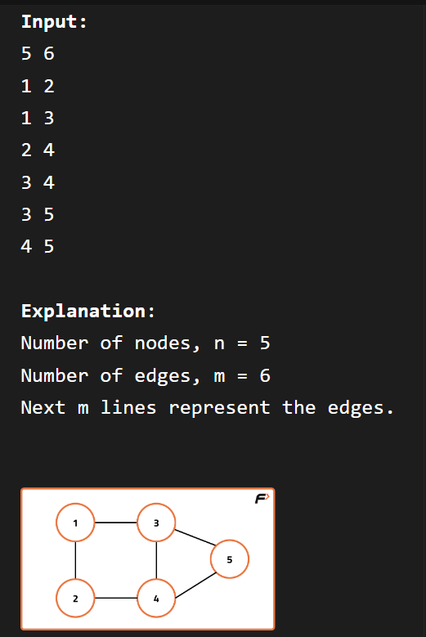
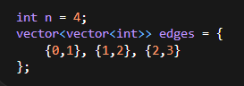
🔸 2 Adjacency Matrix (Given Directly)

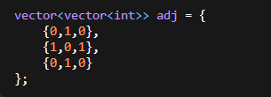
🔸 3 Grid Graph (VERY IMPORTANT)
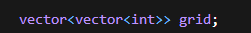
👉 Common in problems like islands

👉 Treat each cell as node
👉 Move in 4 directions

int dx[] = {-1, 0, 1, 0};
int dy[] = {0, 1, 0, -1};

---------------------------------------------------------------------------------------------------------------------------------------------------------

4. Graph Representation

🔹 4.1 Adjacency Matrix

📌 Definition
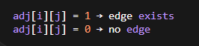
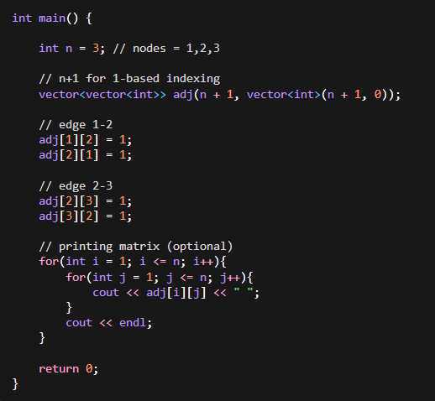

📌 When to Use
• Dense graph
• Small constraints (n ≤ 1000)

❌ Problems
• Memory heavy
• Wastes space

🔹 4.2 Adjacency List (MOST IMPORTANT)
📌 Definition
Each node stores its neighbors
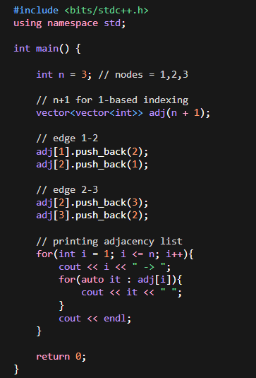
📌 When to Use 90% of problems use this

🔹 4.3 Weighted Graph Representation
📌 Using Pair Meaning adj[u] = {v, weight}
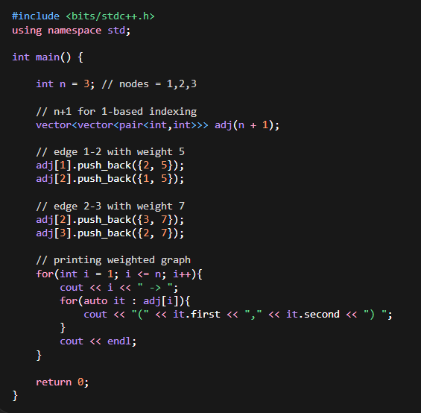

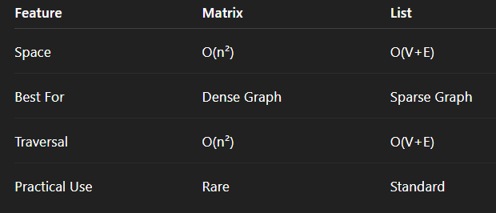

Topological Sort – Notes
🔹 What is Topological Sort?
- Linear ordering of vertices such that:
For every directed edge u → v, u comes before v

🔥 Where is it applicable?
- ✅ Only for Directed Acyclic Graph (DAG)
- ❌ Not possible if cycle exists

🧠 Key Idea
“Independent first, then dependent nodes”

⚡ Methods to Implement
1️⃣ BFS (Kahn’s Algorithm)
- Use indegree
- Steps:
  - Compute indegree of all nodes
  - Push nodes with indegree = 0
  - Pop → add to answer
  - Reduce indegree of neighbors
  - Repeat

2️⃣ DFS + Stack
- Do DFS
- Push node after visiting all neighbors
- Reverse stack → topo order

🔥 Important Properties
- ✔ Topo sort may not be unique
- ✔ Multiple valid answers possible
- ✔ Always linear ordering of nodes
- ✔ Works only for directed graph

⚠️ Cycle Detection Trick (VERY IMPORTANT)
👉 Using Kahn’s Algorithm:
if (topo.size() != V) → cycle exists

🧠 Time & Space Complexity
- Time: O(V + E)
- Space: O(V + E)

